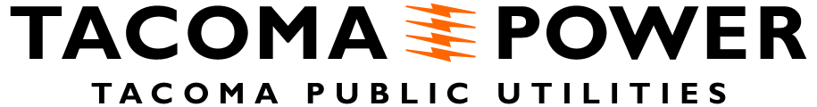

CRR HAP Projects - Project Information Form

Proponent Name, Organization, and Contact Information
Proponent Organization Type (check one)
[ ] Conservation group registered as a non-profit [ ] Native American Tribe
[ ] Regional fisheries enhancement group [ ] Conservation District
[ ] Local and state governmental entity [ ] Federal agency
[ ] Other (describe)

Partner Organization(s) and Type (if any)
Focus Species/Populations
[ ] Spring Chinook (upper Cowlitz/Cispus)
[ ] Coho (upper Cowlitz/Cispus or Tilton)
[ ] Winter Steelhead (upper Cowlitz/Cispus or Tilton)
[ ] Fall Chinook (Upper Cowlitz Basin)

Project Purpose
Project Overview (general description of concept, including approach, rough location, timeline/duration, and any known infrastructure or site requirements)
Specific Location, if Identified (attach Google Map or other map if available), including any existing features that support or constrain the proposal

We recommend starting to develop answers to the questions below now. Our technical advisors can help you or connect you with other resources to work through these topics. Contact Melora Shelton, Tacoma Power Natural Resources Specialist: mshelton@cityoftacoma.org or 253.441.4994 for assistance.

Additional Project Information
Project applications need to include certain types of information to help us evaluate proposals. Specific information may depend on your project type, and may include:

- What is your estimated project cost?
- Where will you get your eggs/fish?
- How many fish can your project support?
- How will you raise your fish (e.g., fish transport, feeding plans)?
- How will you operate and maintain your project (e.g., power and water source, security, access, maintenance)?
- Who will work on your project (e.g., planning, construction, once the project is up and running)?
- What permits do you need?

Evaluation Questions
The following questions will be used to evaluate proposals. You will answer them in the draft application, receive feedback, and re-submit your answers in the final application. You are strongly encouraged to provide descriptions beyond “yes” or “no” answers (e.g., why there are no detrimental impacts for native species, or examples of how the project is aligned with management approaches, etc.). These are draft questions and may be refined before application materials are finalized in late 2022.

Benefits to Fish
- What are the benefits to fish species/populations of interest?
- Does this project have detrimental impacts for any native species in the basin?

Certainty of Success
- Is the scope and approach of the project reasonable and achievable?

Cost
- Is the cost appropriate for/in alignment with the approach?
- Are the benefits to recovery appropriate for the cost?

Program Criteria/Priorities
- How well does the project align with the management approaches and policy described in basin documents (e.g., CRR/CRR implementation strategy, FHMP/FHMP Transition Plan/HGMP/AOP/Monitoring Plan)? You can find these documents, or links to them, at MyTPU.org/CRR.
- Does the project occur in, or have meaningful benefit for, the proper geographic area?

For more information:
- Melora Shelton, Tacoma Power Natural Resources Specialist: mshelton@cityoftacoma.org or 253.441.4994
- MyTPU.org/CRR

